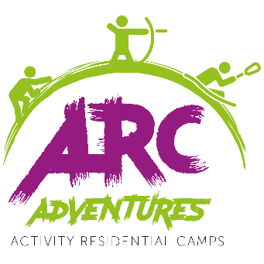
ARC ADVENTURES RESIDENTIAL KIT LIST
Everything you will need to bring with you for your stay away…
Essentials:
- Towel
- Wash Kit (toothbrush, toothpaste, soap, floss)
- Hair bands or scrunchies (if you have long hair)
- Waterproof Jacket & Trousers
- Lunchbox (an ice cream tub will do) & a Water bottle.
- Any medication you take on a regular basis (we are not allowed to give anyone aspirin or paracetamol)
- Enough Clothes for your stay including jumpers or warm jackets + a few extra pairs of socks.
- A pair of good solid trainers or walking boots (they will get muddy)
- A pair of old trainers or wet shoes (which you can ruin as they will be worn in the water)
- Black bag (for wet / dirty clothes)
- Wellies (if caving is on your timetable)
If you have them:
- Indoor shoes
- Torch
- Sun cream
- Hat
- Gloves
- Scarf
- Nightwear
- Sunglasses
- Extra treats + snacks to share
PLEASE DO NOT BRING:
- Mobile phones, tablets or other electronic equipment (there’s no signal anyway.)
- Anything expensive or you don’t want to lose (stuff gets lost or broken when doing activities
- Aerosol’s of any kind.
- Energy Drinks

Activities Consent Form

Details Age (on first day of Event): Years___ Months ___
Full Name: |  |  |  |  |  |  |  |  |  |  | Male Female

All details below to be completed by parent/guardian if under 18
Parent/guardian name(s)
Work Tel |  |  |  |  |  |  |  |  |  | Home Tel
Mobile |  |  |  |  |  |  |  |  |  | Email

Emergency Contact Details (If Different)
Full name |  |  |  |  |  |  |  | Emergency contact number:

Dietary / Behavioural / Medical Matters
Please note any medical or other problems you feel we should know about? (include all details about Asthma, Diabetes, Epilepsy if applicable)
Medicine/Tablets
Allergies
Dietary requirements
(please include religious requirements)
Please note any other issues that you would like us to take into consideration when planning your activities.
Please write YES or NO in the boxes below (if you are unsure please answer NO):
Can swim 50m unaided? |  |  |  |  |  | Can ride a bike confidently? |  |  |  |  | Approximate height: (for sizing of ppe.)

Activity Consent:
I am aware that I (or my child) is going to take part in adventurous activities whilst on residential which inherently hold a degree of risk. Although all attempts are made to reduce any unnecessary danger in activities an integral part of why these activities are challenging is because they contain a real risk of injury. It is impossible to eliminate all danger whilst retaining an integrity in the activity. I am signing to say I have understood the nature of the activities and accept that there must be risk involved. I confirm that I would like to take part in (for the above-named child to take part in) activities delivered by Arc-Adventures. I also consent to any emergency medical treatment necessary during the events including the administration of anaesthetics.
SIGNED (parent/guardian)
Date
Arc Adventures sometimes take photo or video recordings of participants in activities for promotional purposes which could be used in online, or print media, please tick the box below if you are happy for us to do this.

